**DISTANCE & DIRECTIONS**

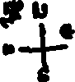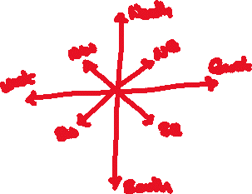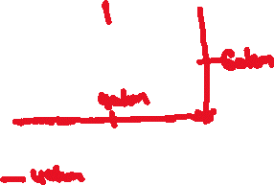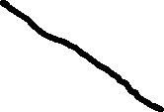

1. A man starts walking towards the East. He turns left, right and finally, he turns right. In which direction is he walking now?  
   1. North 2. East 3. West 4. South



1. A man starts walking towards the South. He turns three times left and two times right. In which direction is he walking now?  
   1. East 2.West 3. North 4. North-West



1. Sowmya starts walking towards North. After walking 60m she turns right and walks 40m. Then she turns right and walks 60m. Finally, she turns left and walks 10m. In which direction is she walking now?  
   1. South 2. East 3. West 4. North



1. Omkar starts walking towards North-East. He turns left, right and finally, he turns left. In which direction is he walking now?  
   1. South-West 2. South-East 3. North-East 4. North-West



1. A man walks 50m in front and 20m to the left. Then he turns left and walks 30m and then he turns right and walks 10m. Finally, he turns left and walks 20m. Now he is moving towards the North. In which direction did he start the journey?  
   1. West 2. South 3. East 4. North



1. A man starts to his right after walking straight. He turns left, right and finally, he turns right. Now he is moving towards the West. In which did he start the journey?  
   1. East 2. North 3. South 4. West



1. A man is facing North, first, he turns in a clockwise direction, then he turns in the anti-clockwise direction. Then in which direction is he facing?  
   1. South-East 2.South-West 3. West 4. None of these



1. A man is facing North-West, first, he turns in a clockwise direction, then he turns in the anti-clockwise direction. Then in which direction is he facing?  
   1. South-West 2. South-East 3. West 4. North-West



1. Sunil is facing East. He turned in the clockwise direction and then turned in the anti-clockwise direction. In which is Sunil facing now?
2. South East 2. North East 3. North West 4. South



1. A man starts walking towards the East. After walking 30 km he turns South and walks 10 km, then he turns East and walks 20 km and finally, he turns North and walks 10 km. In which direction and how far from the starting point?  
   1. 50km. East 2. 50km. South 3. 50km. West 4. None of these



1. A man starts walking towards West. After walking 50m he turns right and walks 30m, then he turns right and walks 50m and finally, he turns right 10m. In which direction and how far from the starting point?  
   1. 10m. North 2. 25m. South 3. 20m. North 4. None of these



1. A man starts walking towards North. After walking 20m he turns right and walks 10m, then he turns right and walks 15m, then he turns right and walks 20m, then he turns left and walks 5m and finally he turns left and walks 10m. In which direction and how far from the starting point?  
   1. 10m. North 2. 10m. West 3. No direction & distance 4. 10m West



1. A man starts walking towards the South. After walking 10km he turns left and walks 4km, then he turns left and walks 10km and finally, he turns left and walks 6km. In which direction and how far to the starting point?  
   1. 1km East 2. 2km West 3. 2km East 4. None of these



1. A man walks 50m in front and he turns left and walks 20m. Then he turns left and walks 30m, then he turns right and walks 10m. Finally, he turns left and walks 20m. How far from the starting point?  
   1. 30m. 2.20m. 3. 40m. 4. None of these



1. A man drives towards the East. After driving 10km he turns right 3km, from there towards West after driving 2 km, then he turns right and drives 9km. How far to the starting point?  
   1. 8 km. 2. 9 km. 3. 10 km. 4. 5 km.



1. Anil walks 20 meters from his school towards North. He then turns left, walks 30meters, again turns left and walks 20 meters. He then turns right and walks 40 meters. The nearest distance and the direction from the school to his present position, is?
2. 50 meters North 2. 70 meters South 3. 70 meters West 4. 50 meters West



1. A man stats walking towards East. After walking 50m he turns left and walks 60m, then he turns left and walks 30m. In which direction and how far from the starting point?  
   1. 20 North-West 2. 20 North-East 3. 20 South-East 4. None of these



1. A is 6km to the East of B.C and 4km to the North of B. D is 12km to the South of C. How far and in which direction is D from A?  
   1. 10 KM South-West 2. 10 KM North-West 3. 5 KM East 4. None of these



1. A is 5km to the South-West of B is 5km to the South-East of C. D is 3km to the North of C. Where is D?  
   1. To the northeast of A 2. To the South of A 3. To the North of A 4. None of these



1. If South-East is called North, and North-East is called West, then what will West be called?  
   1. South-West 2. South-East 3. North-West 4. None of these



1. If South-East is called South-West, and South is called West, then what will North-East be called?  
   1. North-West 2. South-West 3. South-East 4. None of these



1. If a clock shows 9:00 as the time, and its Hour hand is facing North, then which direction is the minute hand facing.?  
   1. West 2. North 3. East 4. None of these



1. If a clock shows 2:20 as the time, and its minute hand is facing West, then which direction is the hour hand facing.?  
   1. North-East 2. South-West 3. South-East 4. None of these

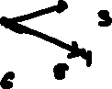

1. One morning your shadow is falling to your left, then in which direction are you facing?  
   1. North 2. East 3. West 4. None of these



1. One evening You and Your friend stood face to face by shaking hands. The shadows are falling to the right of your friend, then in which direction you are facing?  
   1. North 2. East 3. West 4. None of these



1. Anya and Manya are standing facing each other. Anya is facing North-West. Which direction is facing for Anya?  
   1. South-East 2. North-East 3. South-West 4. None of these



1. R is East of P.S is East of R. Y is South of S and Z is South of P then Y is in which direction of Z?  
   1. Can’t say 2. East 3. West 4. North-East



1. M is West of L.N is North of M. O is East of L and P is South of O then P is in which direction of N?  
   1. Can’t say 2. South-West 3. South-East 4. North-West

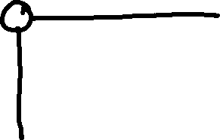

1. Four members A, B, C and D play a game of cards. A and B are partners. A is sitting in the East facing, is left of C. Who is sitting in the North facing?  
   1. C 2. D 3. B 4. None of these



1. Ramya wants to go to college. She starts from her home which is in the East and comes to the crossing. The road to the left ends in a market and straight ahead is the cinema theatre. In which direction in the college?  
   1. North 2. East 3. West 4. None of these

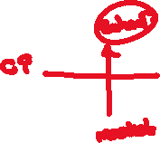

**🖎 ☺ ~ విజయీభవ ~ ☺ ✍**